

**Asia Pacific College**

**School of Computing and Information Technologies**

**Structured Systems Analysis and Design 1**

**BUS QUEUEING SYSTEM**

Gomez, Raxell  
Magcayang, Aaron Jester  
Serra, Vincent Franklin

**TABLE OF CONTENTS**

1. **Introduction……………………………………………………………..…………………..3  
   1.1 Project Context…………………………………….………………………………..3**

**1.2 Purpose and Description………………………….………………………………...3**

**1.3 Objectives…………………………………………………………………………....3**

**1.4 Scope and Limitations………………………………………………………………3**

1. **Review of Related Literature…………….…………………………………………………4**
2. **List of Diagrams………….……………………………………………………………….…5**

**3.1 Event Table………………………………………………………………………......5**

**3.2 Use Case Diagram and Use Case Description…………………………………..6-14**

**3.3 Context Flow Diagram………………………….………………………………….15**

**3.4 Data Flow Diagram lvl 0………………………………….………………………..16**

**3.5 Activity Diagram ………………………………………………………………..17-21**

**3.6 Sequence Diagram ………………………………………………………………22-28**

**3.7Entity Relationship Diagram…………….………...………………….……….......29  
 3.8 State Machine Diagram……… …………….………...……………………........30-34**

**3.9 Timing Diagram……………… …………….………...…………………….......35-40**

**3.10 Communication Diagram……………..…….………...…………………….........41**

**3.11 Deployment Diagram……………..…….………...……………………................41**

**3.12 Class Package Diagram…..….………...…………………….…………................42**

**3.13 Component Diagram…..….………...…………………….…………....................43**

1. **Gap Analysis…………………………………………………………………………………44**
2. **SWOT Analysis………………………………………………………………………..........44**
3. **Conclusion and Recommendation………………………….………………………............45**
4. **Data Gathering..………………………………………………………………………..........46-50**
5. **References……..………………………………………………………………………..........50**
   1. **Introduction**
   2. **Project Context**

* Because of the growing population of Asia Pacific College, surely there will be a lot of students/staffs that needs to line up in order to ride the shuttle. The problem is, due to fear of not falling in line early, even though the shuttle’s not there, students/staffs will fall in line early as they can and won’t have the time to do the things that they need (eg. Eat, appointments with professors, Projects meetings).
  1. **Project Description**
* Bus Queue Monitoring System will provide hassle-free, convenient application so students can use the time for other important things to be done rather than queuing. Not only students have the benefits in this project but also the staffs/professors for they can use the time on their appointments with their students. They can buy food at the cafeteria instead of queueing. This project may also come to use. In addition, to obtain new knowledge of what/when is the most students that will queue will do their best to follow schedule in-case of emergency maintenance of other buses. To provide data of when are the most students/staffs queue in a specific time
  1. **Objectives**
* To develop and create a convenient queuing system for Asia Pacific College students and staffs
* To develop and create an application where students/staffs can fall in line to ride the shuttle without going down.
* To lessen the students who fall in line to ride the bus.
  1. **Scope and Limitations**
* It gives reservation number to users who are to use the bus services
* The following constraints apply to the Bus Queue System. As project planning beings and more constraints are identified, they will be added immediately.
* The team has only limited knowledge available to create the system.
* As implementation will be done internally and not by the product developers or vendors, experts, there will be limited support from the hardware/software providers.
* Student without smart phones can’t use the application.
* Asia Pacific College has the limited area of internet connectivity making the application not accessible (only for the students/staffs that doesn’t have mobile data) anywhere/anytime at the said school.
* The Internet Connection will only be available in Cafeteria & 7th floor (library)
* The team is not eligible to provide Internet Connection for those who don’t have an Internet
  1. **Review of Related Literature**

**Automated Queue Management System**

In a study made by Uddin, N. et. Al (2016), they have developed an automated queueing management system that can resolve the queueing problems that are being faced in a bank. With the automated queueing system, the application itself analyzes the current status of the queue and provides a decision on which client to serve, taking into consideration the average waiting time. This provides a cost and time efficient way of service. During their simulation, random generated numbers were used to represent each client’s arrival time and service chosen, with the queueing system it made the transactions a little faster compared to the average queueing system that were previously used.

**Qminder Queueing System**

A transportation company in Qatar, Mowasalat, uses a Qminder queueing system that shows drivers the queueing status after signing up. The application provides details that inform users their status and where to go next. It also replaced the numbered tickets that were previously used to a name basis to have more personal and friendly approach. The implementation of this management system solved unbearable waiting times and made the process of their company much smoother.

* 1. **List of Diagrams**

**3.1 Event Table**

|  |  |  |  |  |  |
| --- | --- | --- | --- | --- | --- |
| Event | Trigger | Source | Use Case | Response | Destination |
| User wants to create an account | Registration | User | User Registration | Account created | System |
| User wants to login to the system | Login | User | User Log-in | Successfully logged in | User |
| User wants to reset his/her password | Incorrect user account password | User | Reset Password | Password reset successfully | System |
| User wants to know the current location of the bus | Request for current location | User | Check current bus location | Display current location | User |
| User wants to know the bus schedule | Request for bus schedule | User | Check bus schedule | Display bus schedule | User |
| User wants to reserve a seat for bus | Queuing | User | User reserve a seat for bus services | Reserve successfully | User |
| Admin needs the report for daily, weekly, monthly and yearly bus queuing | Request for reservation report | Admin | Reservation report | Reservation report generated | Admin |
| Admin wants to edit the bus information | Change of bus availability or schedule | Admin | Edit bus information | Bus information updated | System |

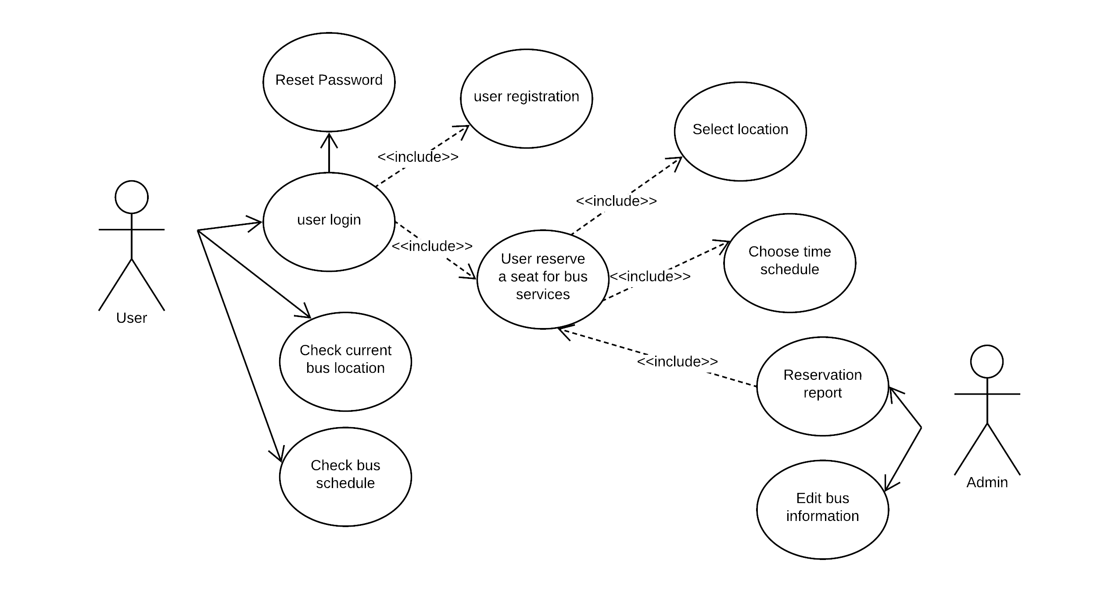**3.2 Use Case Diagram and Use Case Full Description**

|  |  |  |
| --- | --- | --- |
| Use Case Name | User Registration | |
| Scenario | User wants to create an account | |
| Triggering Event | Registration | |
| Brief Description | User wants to create an account in Bus Queuing System | |
| Actors | User | |
| Related Use Case |  | |
| Stakeholders | User | |
| Preconditions | * User must have installed the Bus Queuing System on his/her device * User must have internet connection | |
| Postconditions | The account created must be placed inside the database | |
| Flow of Activities | Actor | System |
| 1. User opens the Bus Queuing System application |  |
|  | * 1. System display sign-in/signup page |
| 1. User clicks signup |  |
|  | * 1. System display signup form |
| 1. User fills out the signup form |  |
|  | 3.1 System accepts the user information and inserted it in the system’s database |
|  | * 1. System inserts information in the system’s database |
| Exception Conditions | * User has not installed the application in the device * User has no internet connection | |

|  |  |  |
| --- | --- | --- |
| Use Case Name | User Login | |
| Scenario | User wants to login to the system | |
| Triggering Event | Registration | |
| Brief Description | User wants to login his/her account in Bus Queuing System | |
| Actors | User | |
| Related Use Case |  | |
| Stakeholders | User | |
| Preconditions | * User must have installed the Bus Queuing System on his/her device * User must have internet connection * User must have created an account | |
| Postconditions | User will go directly to the main page | |
| Flow of Activities | Actor | System |
| 1. User opens the Bus Queuing System application |  |
|  | * 1. System display sign-in/signup page |
| 1. User clicks sign-in |  |
|  | * 1. System display sign-in form |
| 1. User fills out the sign-in form |  |
|  | * 1. System accepts the user account |
|  | * 1. System display Bus queuing system main page |
| Exception Conditions | * User has not installed the application in the device * User has no internet connection * User has no account in the system * User has wrong credentials | |

|  |  |  |
| --- | --- | --- |
| Use Case Name | Reset Password | |
| Scenario | User wants to account | |
| Triggering Event | Incorrect account password | |
| Brief Description | User wants to create an account in Bus Queuing System | |
| Actors | User | |
| Related Use Case |  | |
| Stakeholders | User | |
| Preconditions | * User must have installed the Bus Queuing System on his/her device * User must have internet connection * User must have created an account | |
| Postconditions | The account update must be placed inside the database | |
| Flow of Activities | Actor | System |
| 1. User opens the Bus Queuing System application |  |
|  | * 1. System display sign-in/signup page |
| 1. User clicks sign-in |  |
|  | 2.1 System display sign-in page |
| 1. User clicks reset password |  |
|  | * 1. System display reset password page and form |
| 1. User fills out the reset password form |  |
|  | * 1. System accepts user password input |
|  | * 1. System update the system’s database |
| Exception Conditions | * User has not installed the application in the device * User has no internet connection * User has no account in the system * User has successfully signed in | |

|  |  |  |
| --- | --- | --- |
| Use Case Name | Check current bus location | |
| Scenario | User wants to know the current location of the bus | |
| Triggering Event | Request for current location | |
| Brief Description | User wants to know where exactly the bus is located | |
| Actors | User | |
| Related Use Case |  | |
| Stakeholders | User | |
| Preconditions | * User must have installed the Bus Queuing System on his/her device * User must have internet connection * User must have signed in his/her account | |
| Postconditions | The current location of the bus must be given | |
| Flow of Activities | Actor | System |
| 1. User successfully signed in |  |
|  | 1. System display main page |
| 1. User clicks bus current location |  |
|  | 1. System verifies details in the database |
|  | 1. System display bus current location map |
| Exception Conditions | * User has not installed the application in the device * User has no internet connection * User has no account in the system * User is not successfully signed in | |

|  |  |  |
| --- | --- | --- |
| Use Case Name | Check bus schedule | |
| Scenario | User wants to know the bus schedule | |
| Triggering Event | Request for bus schedule | |
| Brief Description | User wants to know the exact bus schedule | |
| Actors | User | |
| Related Use Case |  | |
| Stakeholders | User | |
| Preconditions | * User must have installed the Bus Queuing System on his/her device * User must have internet connection * User must have signed in his/her account | |
| Postconditions | The bus schedule must be given | |
| Flow of Activities | Actor | System |
| 1. User successfully signed in |  |
|  | * 1. System display main page |
| 1. User clicks bus schedule |  |
|  | * 1. System verifies details in the database |
|  |  | * 1. System display bus schedule page |
| Exception Conditions | * User has not installed the application in the device * User has no internet connection * User has no account in the system * User is not successfully signed in | |

|  |  |  |
| --- | --- | --- |
| Use Case Name | User reserve a seat for bus services | |
| Scenario | User wants to reserve seat for bus | |
| Triggering Event | Queuing | |
| Brief Description | User wants to reserve seat to ride the bus | |
| Actors | User | |
| Related Use Case |  | |
| Stakeholders | User | |
| Preconditions | * User must have installed the Bus Queuing System on his/her device * User must have internet connection * User must have signed in his/her account | |
| Postconditions | User successfully reserved a seat | |
| Flow of Activities | Actor | System |
| 1. User successfully signed in |  |
|  | * 1. System display main page |
| 1. User clicks queue |  |
|  | * 1. System receives the queuing of user |
|  |  | * 1. System generates reservation number |
| Exception Conditions | * User has not installed the application in the device * User has no internet connection * User has no account in the system * User is not successfully signed in | |

|  |  |  |
| --- | --- | --- |
| Use Case Name | Reservation report | |
| Scenario | Admin needs the report for bus queuing | |
| Triggering Event | Request for reservation report | |
| Brief Description | Admin needs the daily, weekly, monthly and/or yearly report for bus queuing | |
| Actors | Admin | |
| Related Use Case |  | |
| Stakeholders | Admin | |
| Preconditions | * Admin must have permission access in Bus Queuing System * Admin must have internet connection * Admin must have signed in his/her account | |
| Postconditions | User must be given his/her reservation number | |
| Flow of Activities | Actor | System |
| 1. Admin clicks reservation report |  |
|  | * 1. System display reservation report page |
| 1. Admin must choose among: daily, weekly, monthly or yearly |  |
|  | * 1. System generates reservation report |
| Exception Conditions | * Admin has no permission access on the application * Admin has no internet connection * Admin has no account in the system * Admin is not successfully signed in | |

|  |  |  |
| --- | --- | --- |
| Use Case Name | Edit bus information | |
| Scenario | Admin wants to edit the bus information | |
| Triggering Event | Change of bus availability or schedule | |
| Brief Description | Admin needs to update the status of the bus in terms of maintenance or use | |
| Actors | Admin | |
| Related Use Case |  | |
| Stakeholders | Admin | |
| Preconditions | * Admin must have permission access in Bus Queuing System * Admin must have internet connection * Admin must have signed in his/her account | |
| Postconditions | User must be given his/her reservation number | |
| Flow of Activities | Actor | System |
| 1. Admin clicks edit bus information |  |
|  | * 1. System display edit bus information page |
| 1. Admin change information of the bus |  |
|  | * 1. System accepts change in bus information |
|  | * 1. System update the bus information in the database |
| Exception Conditions | * Admin has no permission access on the application * Admin has no internet connection * Admin has no account in the system * Admin is not successfully signed in | |

* 1. **Context Diagram**

A close up of a logo

Description generated with very high confidence

**In this diagram show the overview of Context Diagram**

**3.4 Data Flow Diagram (lvl 0)**

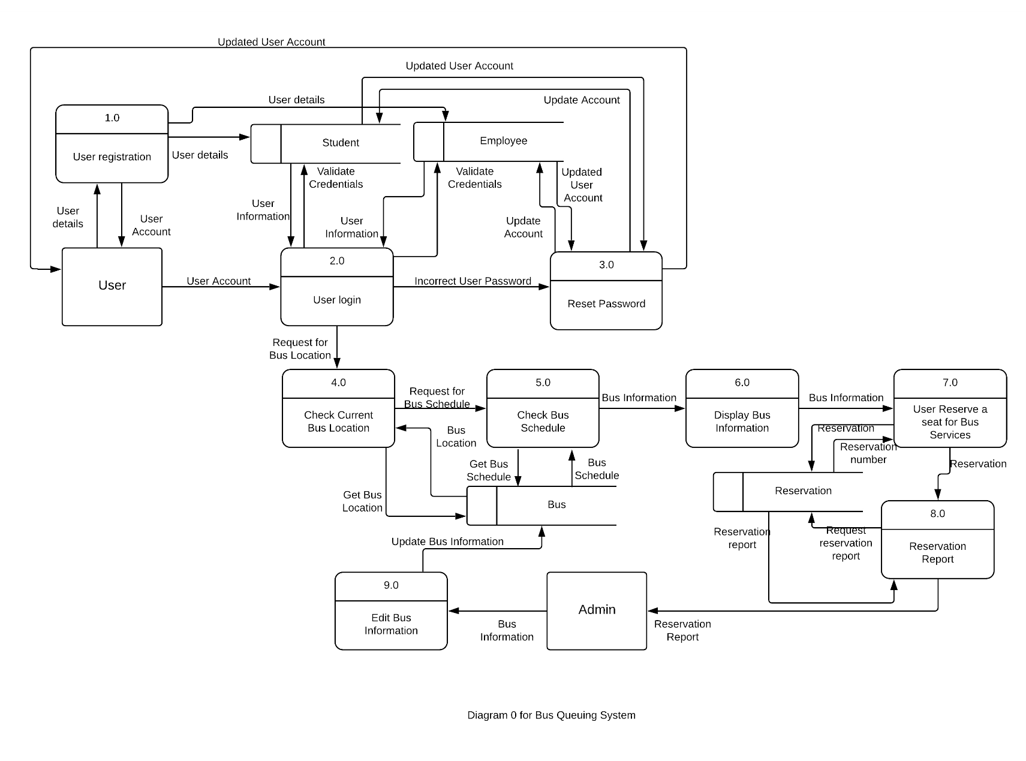**Data Flow Diagram Level 0 as shown above, It shows how the process works or the flow of the process.**

**3.5 Activity Diagram**

**a. User Registration**

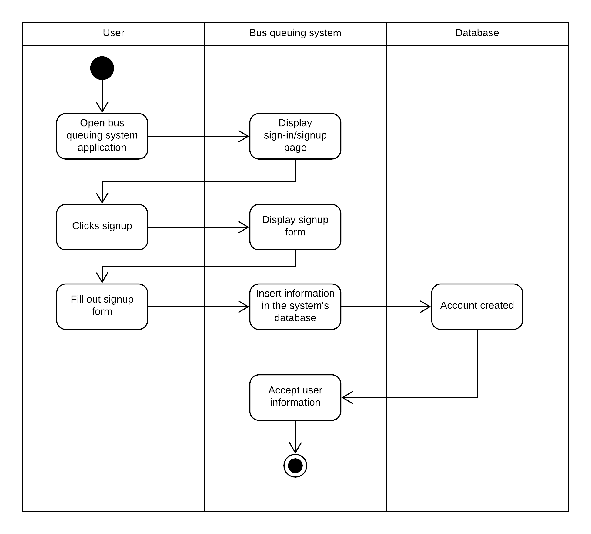

**When User Registers, it shows how the process works.**

**b. User Login**

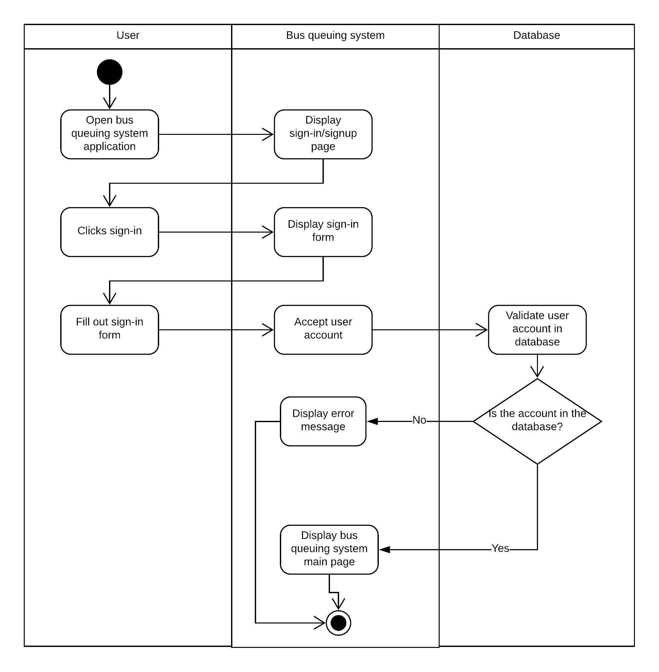

**User Login Activity Diagram.**

**c. Reset Password**

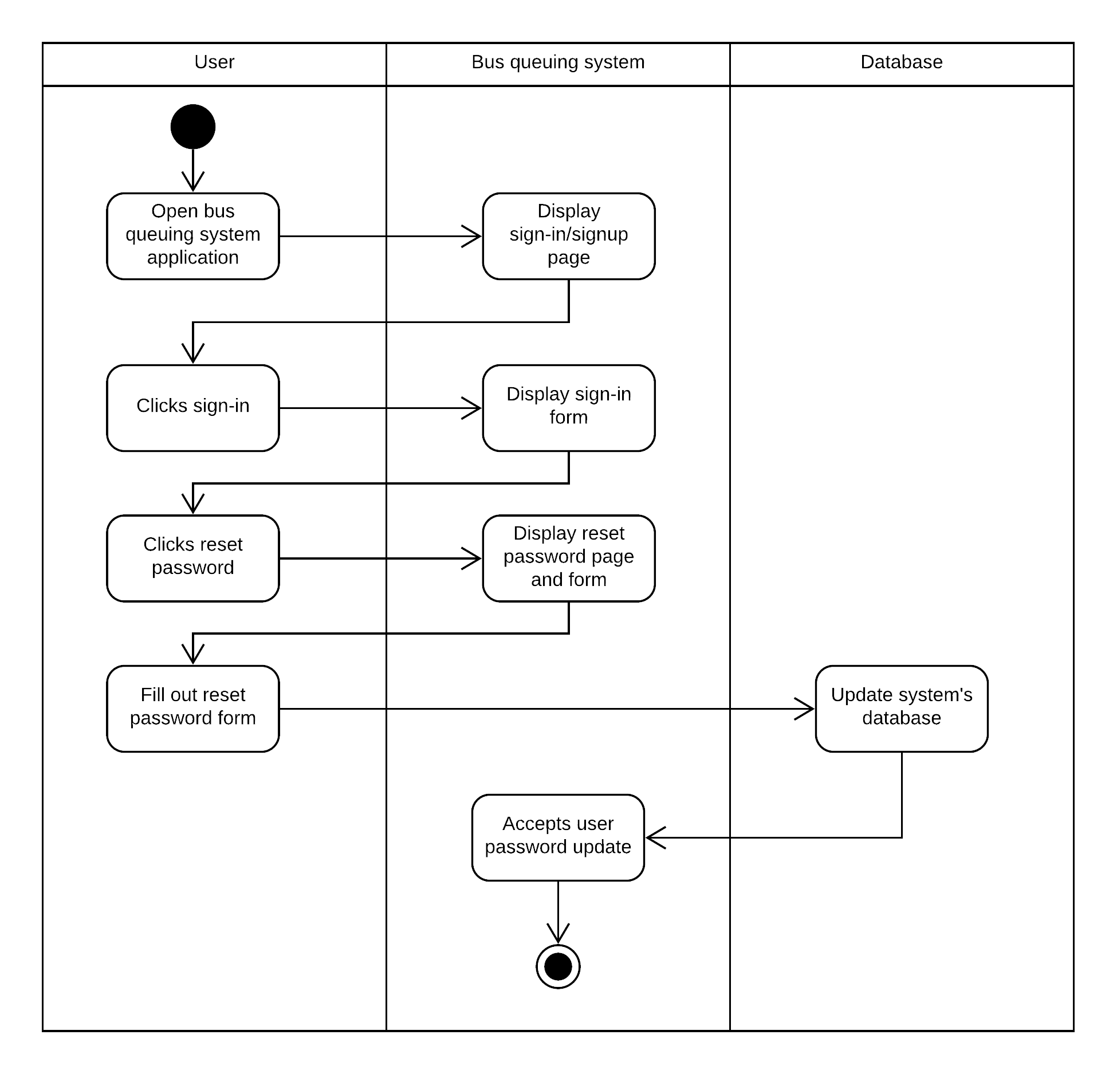

**Reset Password Activity Diagram.**

**d. Bus Location**

**Bus Location Activity Diagram.**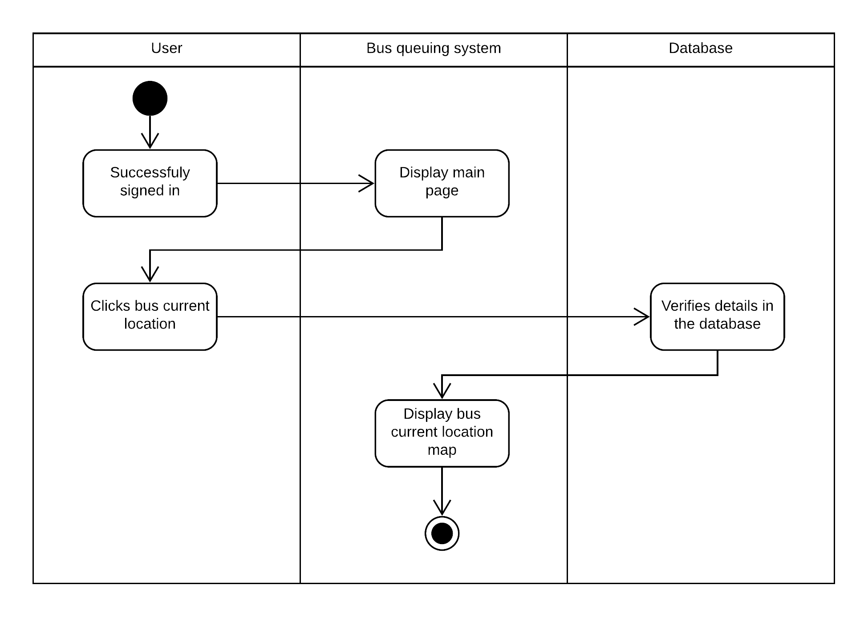

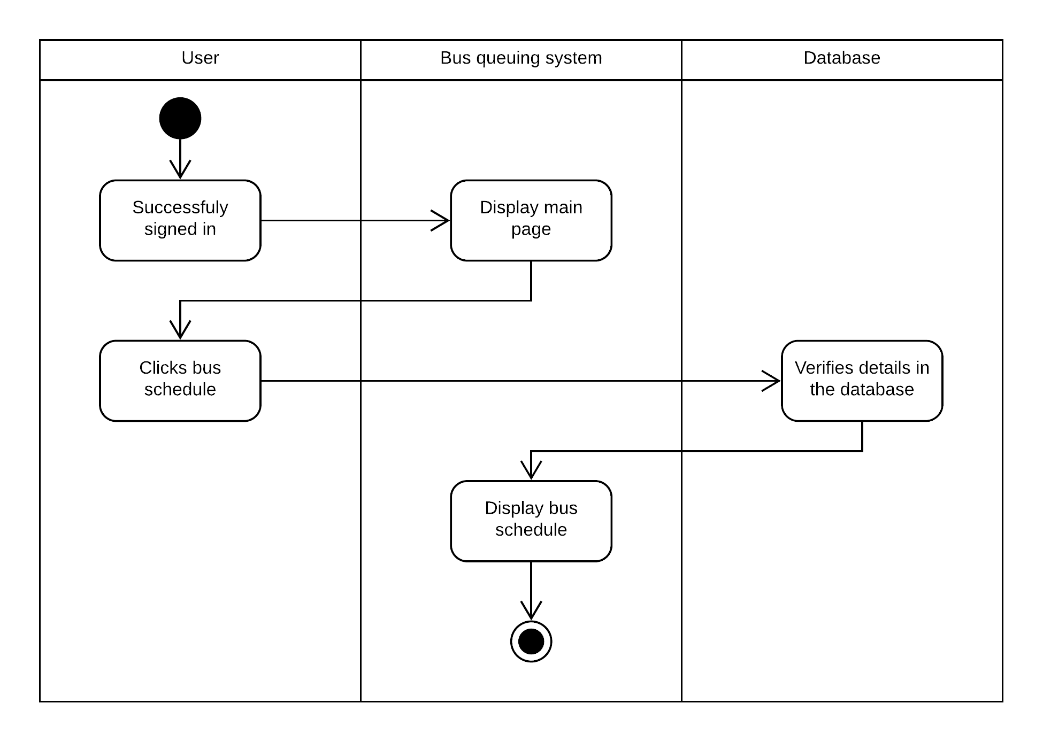**e. Bus Schedule**

**f. Reserve**

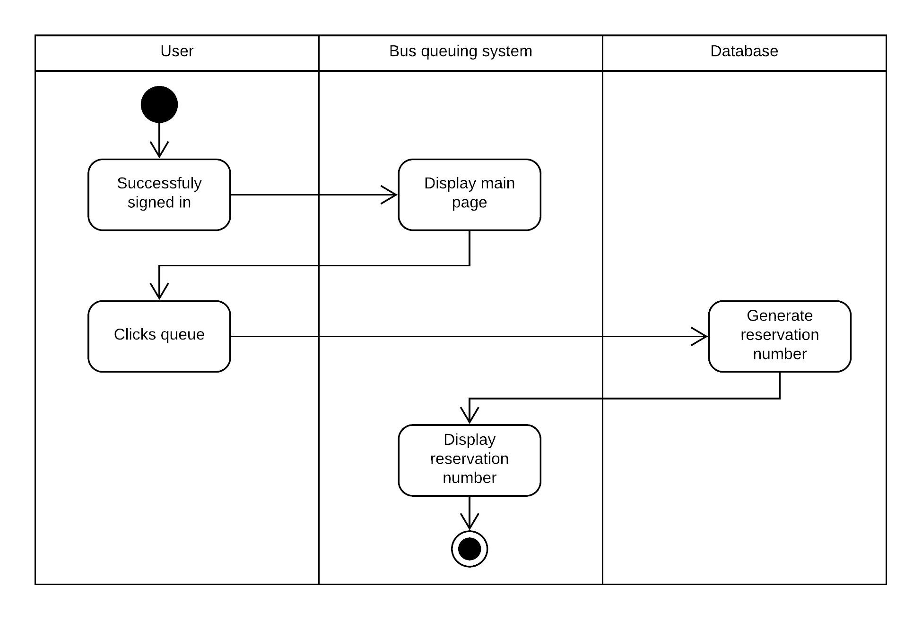**Reserve Activity Diagram.**

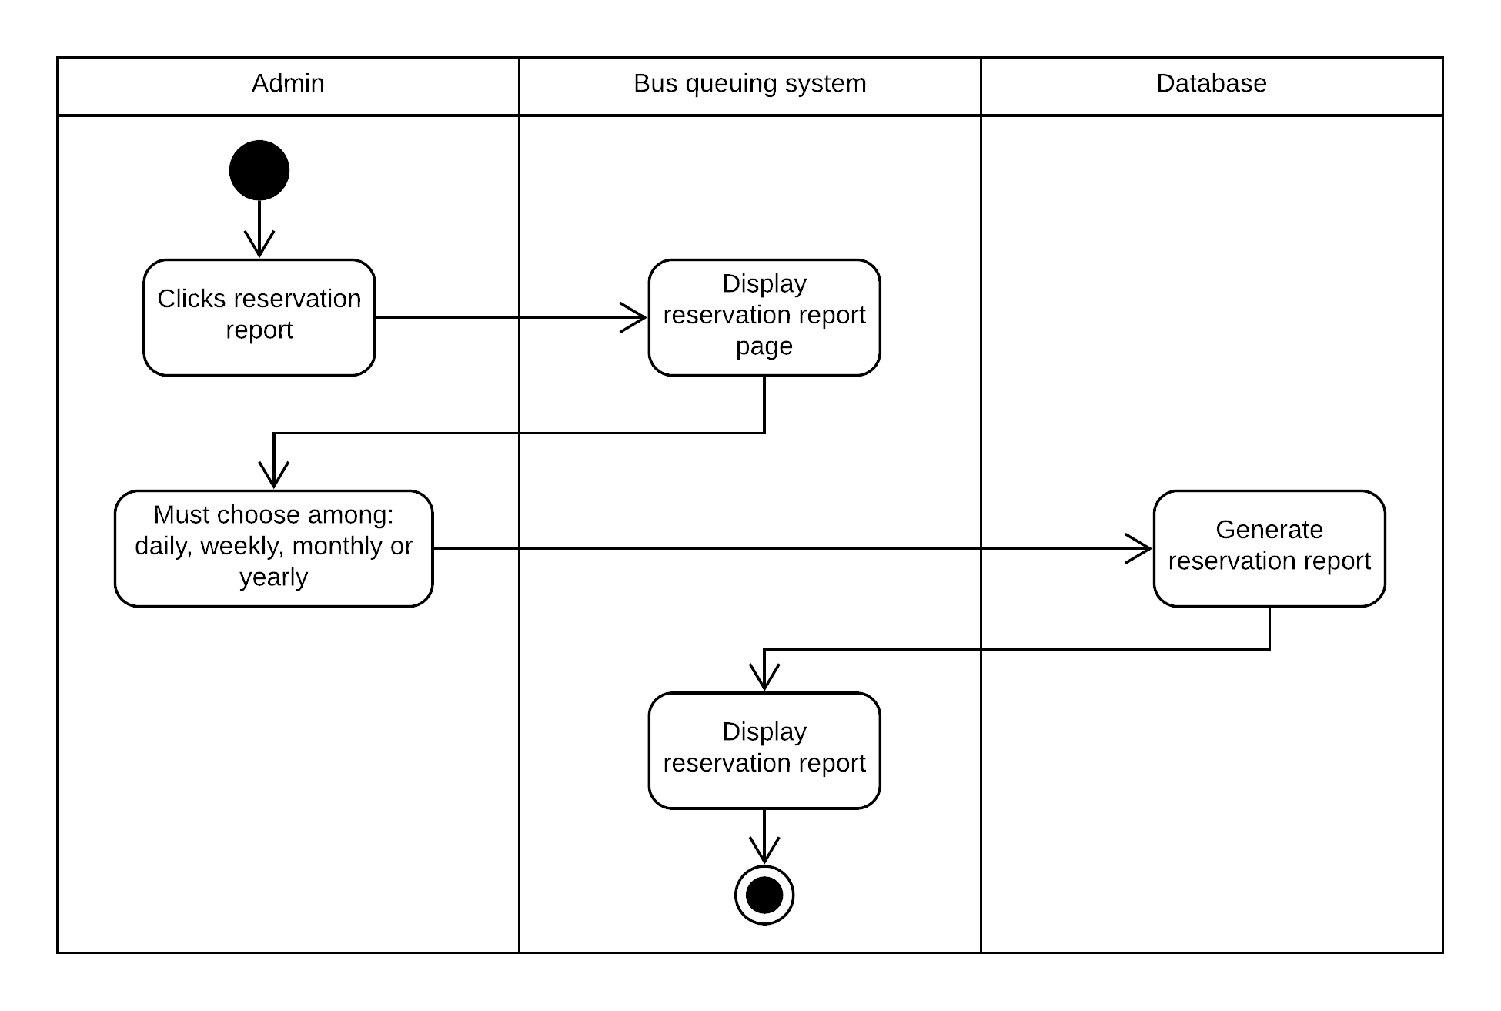**g. Reservation Report  
Reservation Report Activity Diagram**

**3.6 Sequence Diagram**

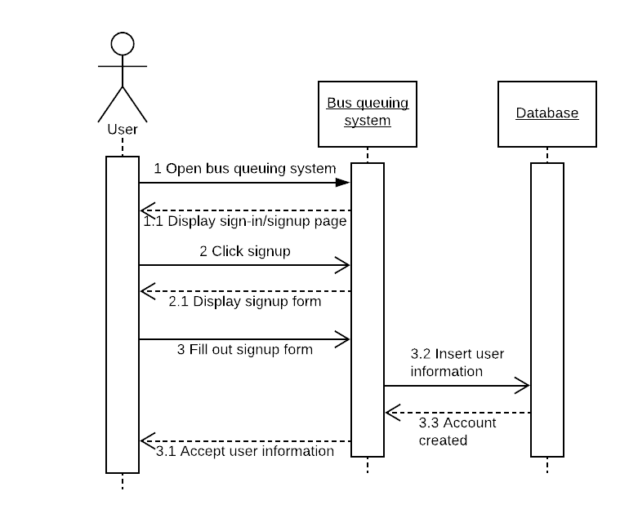 **a. User Registration**

**User Registration**

**b. User Login**

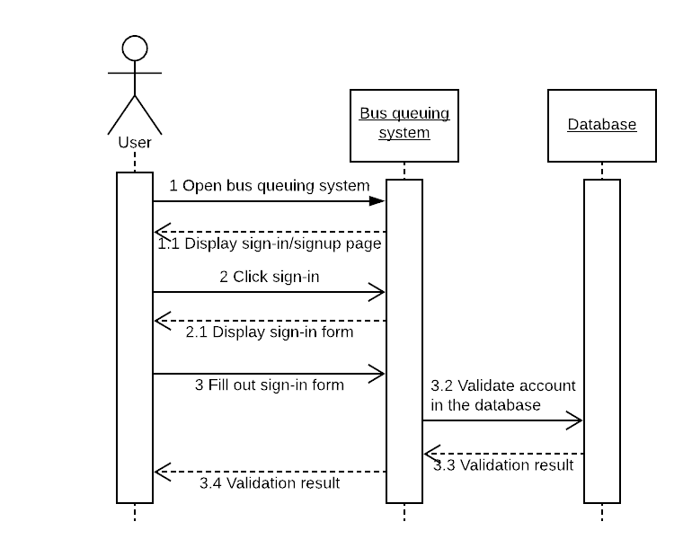

**User Login Sequence Diagram**

**c. Reset Password**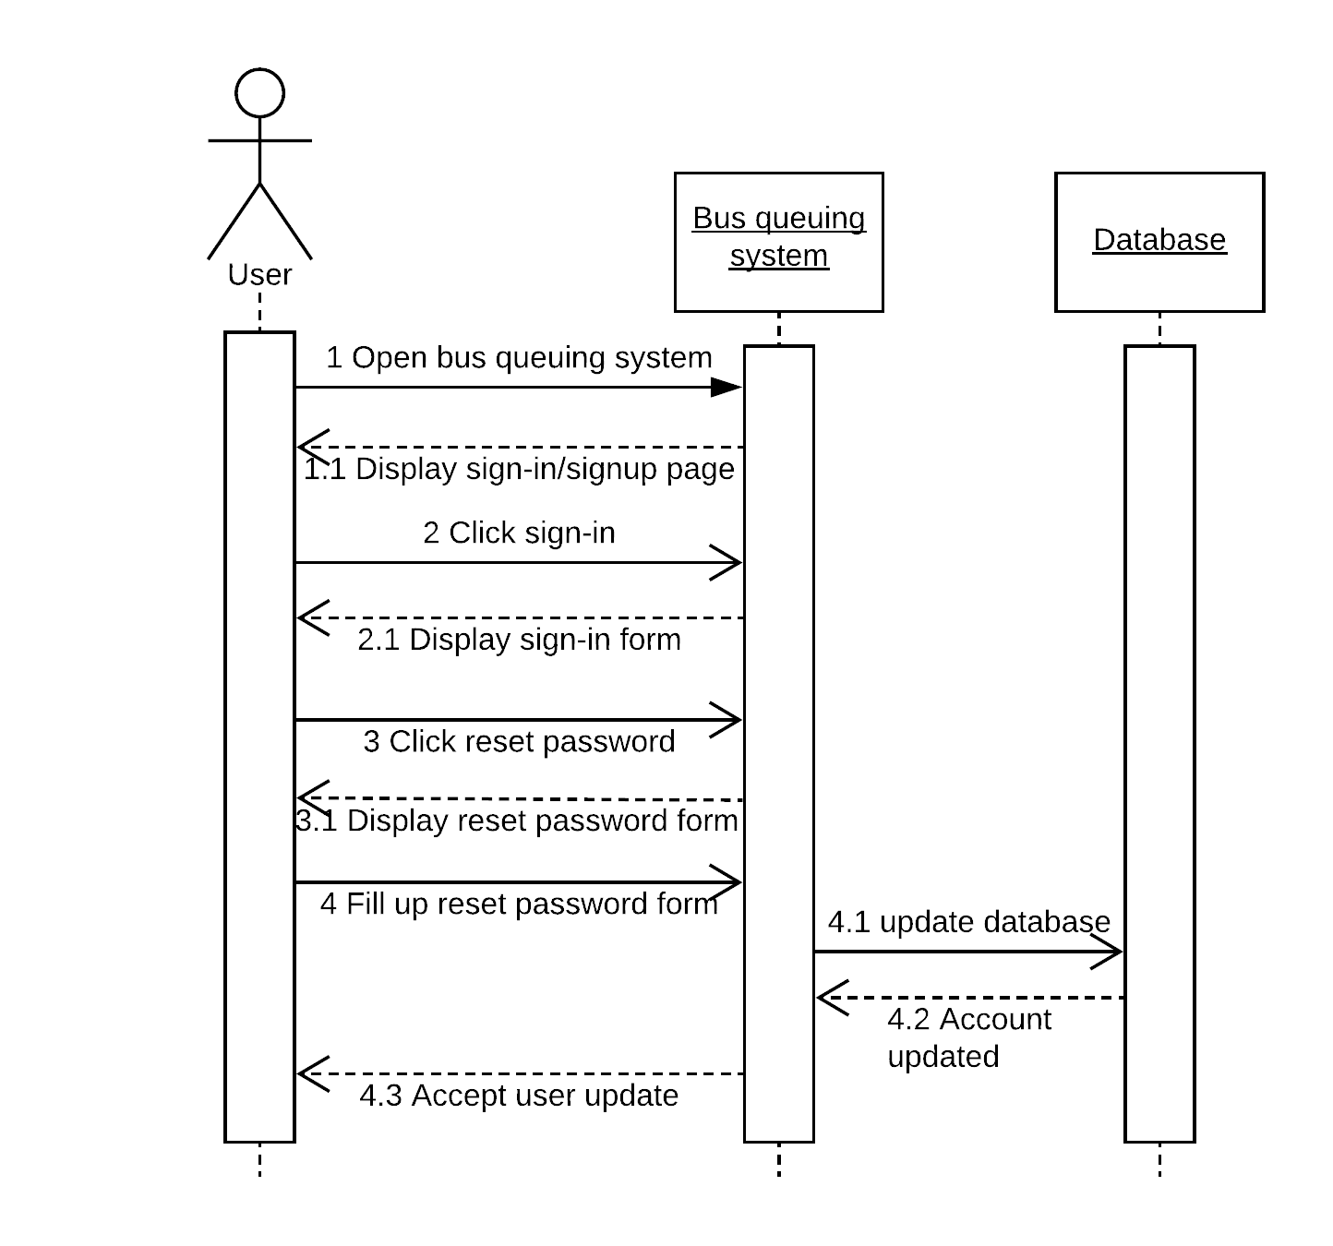

**Reset Password Sequence Diagram**

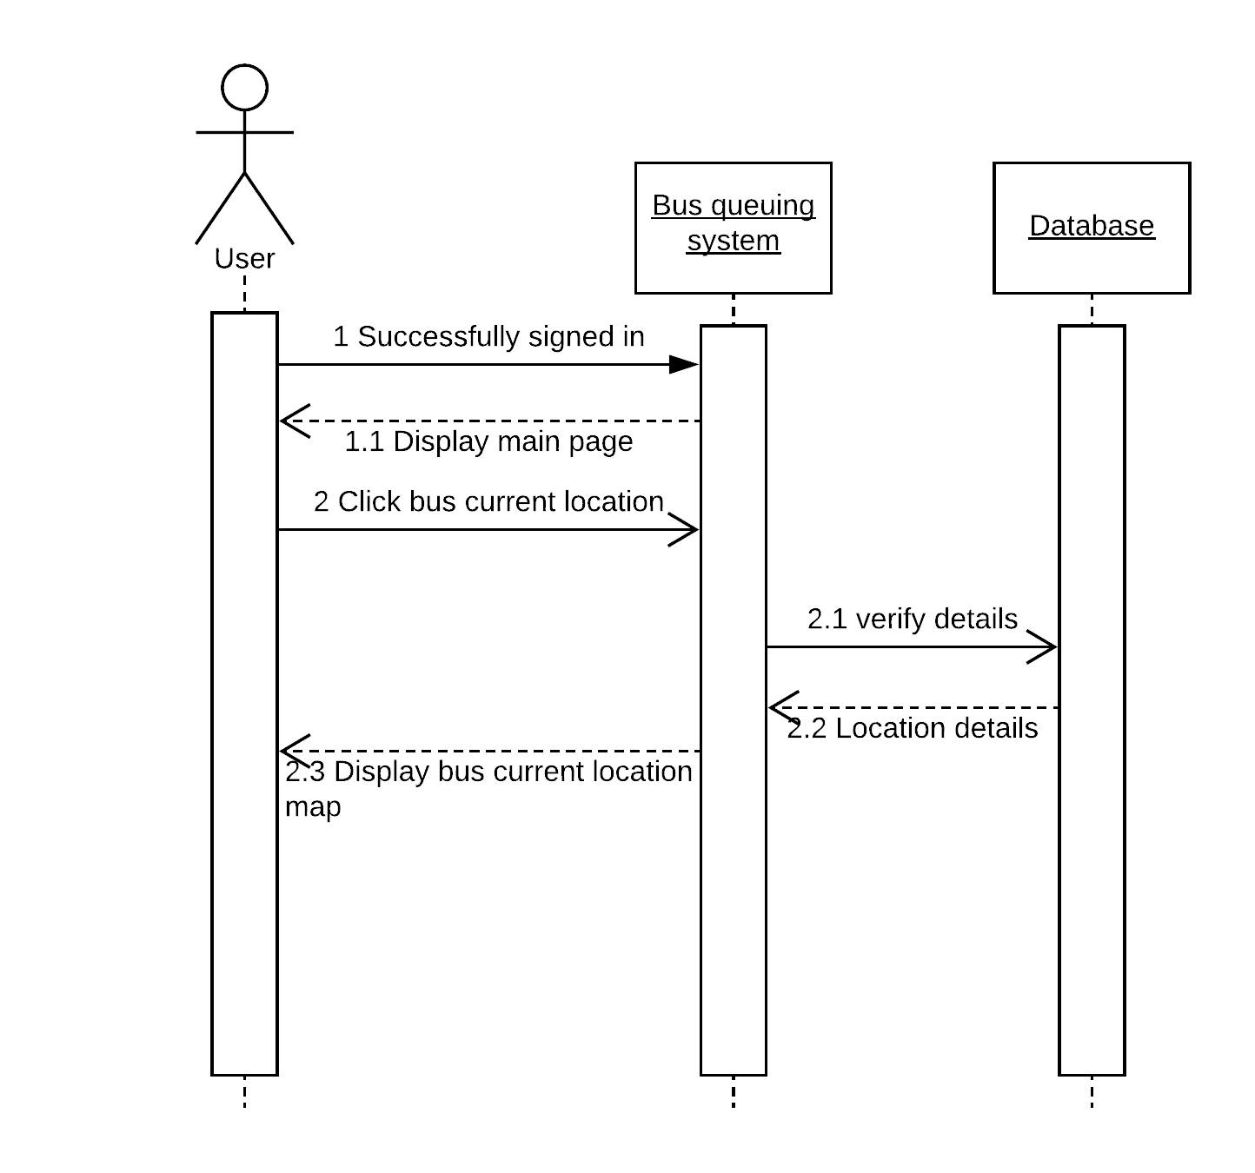**d. Bus Location**

Bus Location **Sequence Diagram**

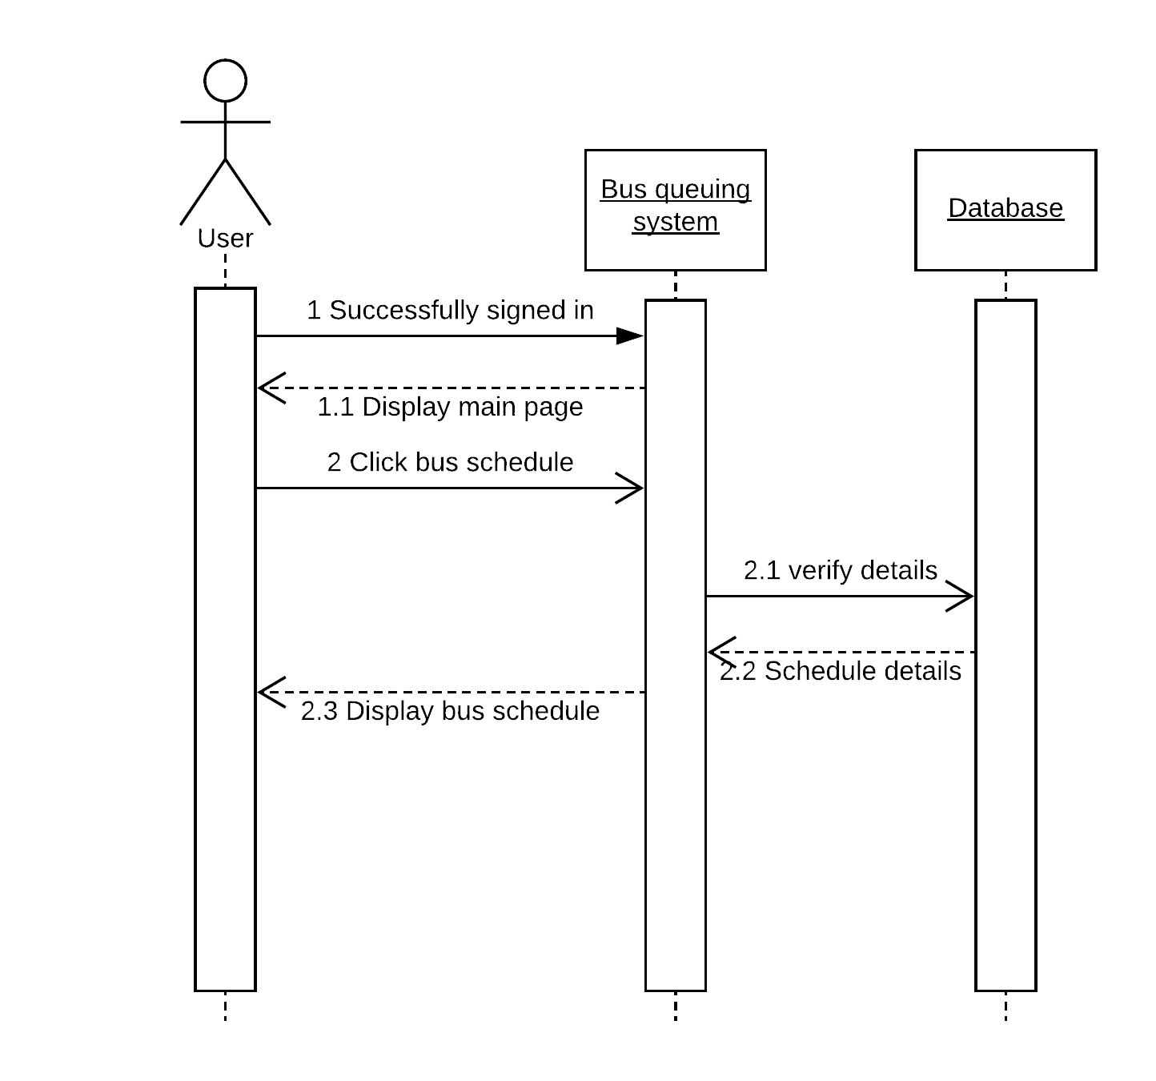 **e. Bus Schedule**

**Bus Schedule Sequence Diagram**

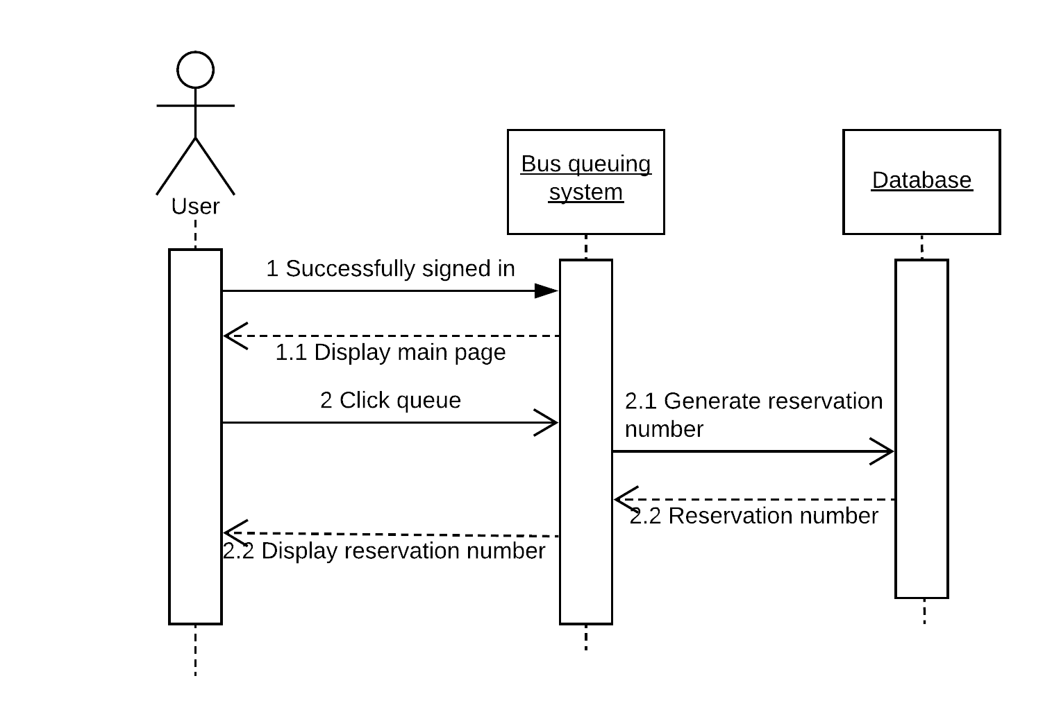**f. Reserve**

**g. Reservation report**

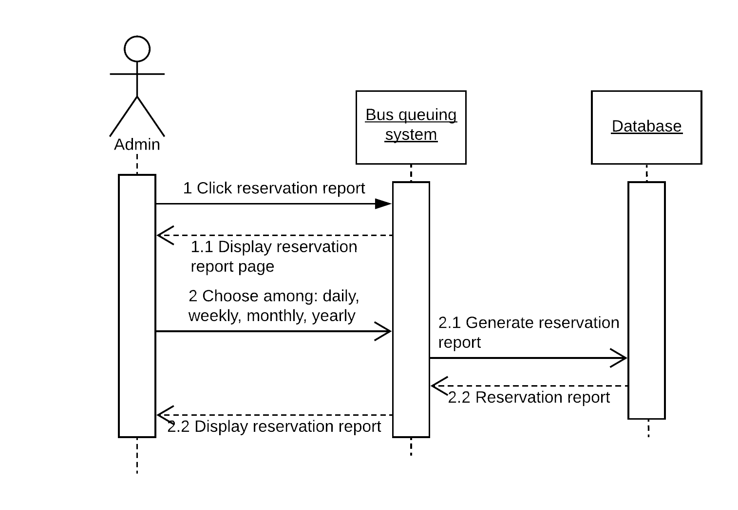

Reservation Report **Sequence Diagram**

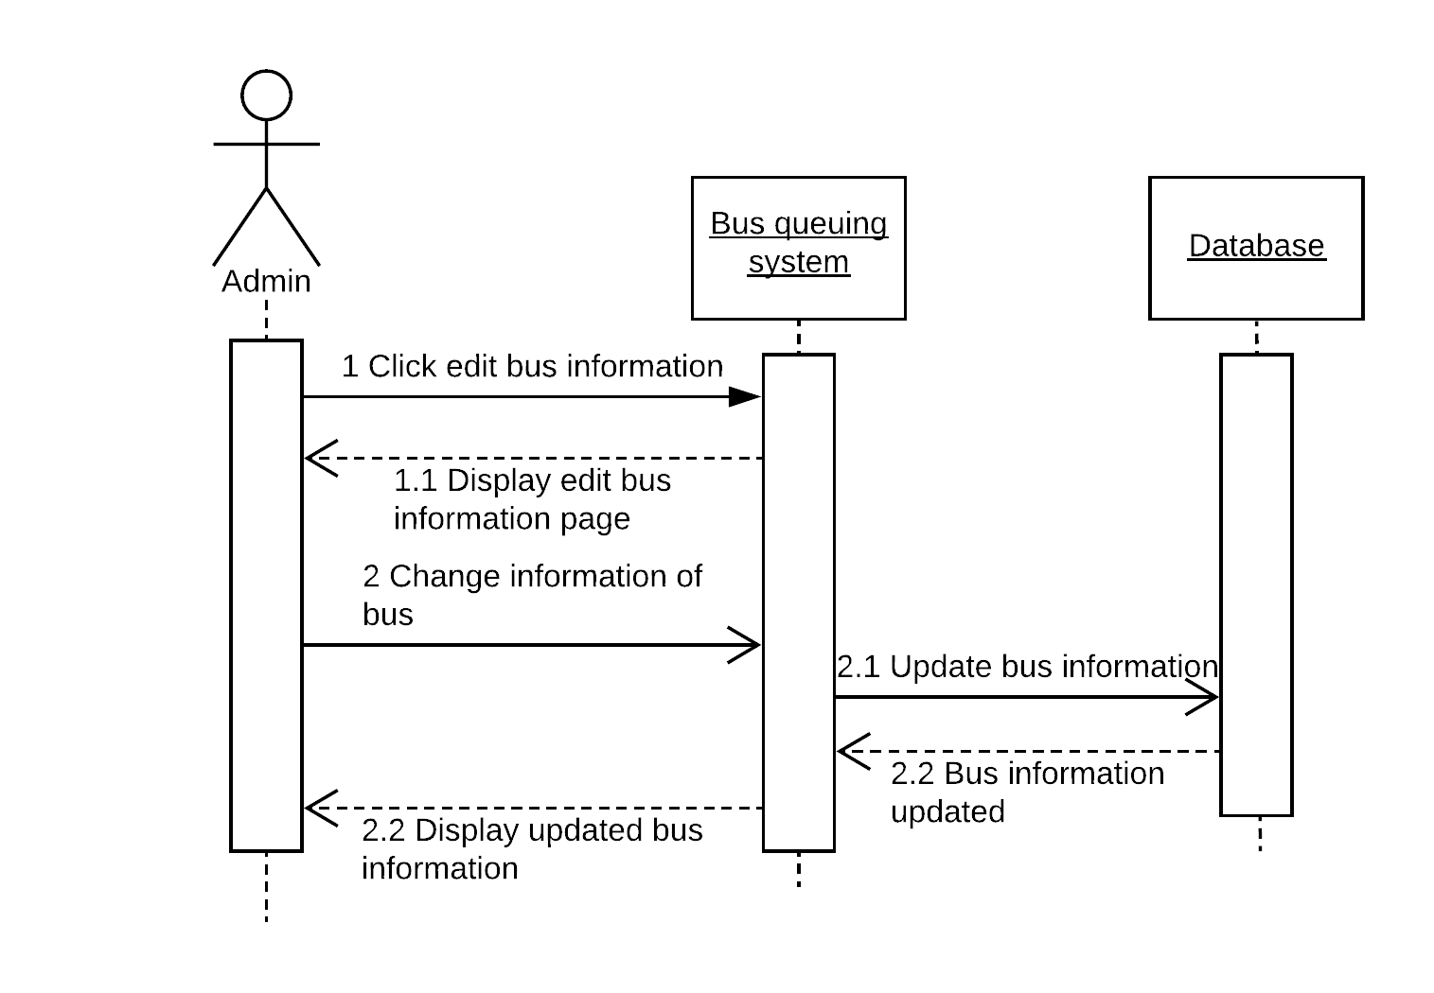 **h. Edit bus**

Edit Bus **Sequence Diagram**

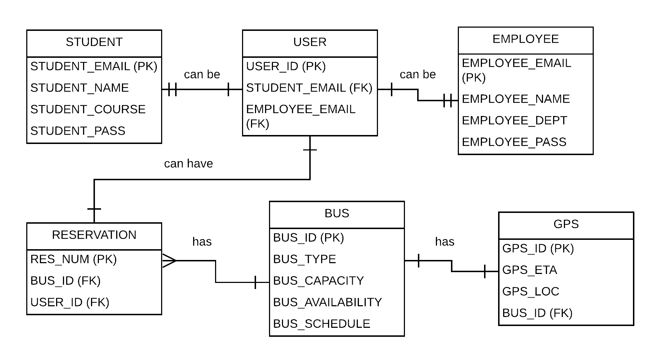 **3.7 Entity Relationship Diagram**

**ERD Attributes**

**STUDENT**

**USER**

**EMPLOYEE**

**RESERVATION**

**BUS**

**GPS**

**3.8 State Machine Diagram**

**a. User Registration**

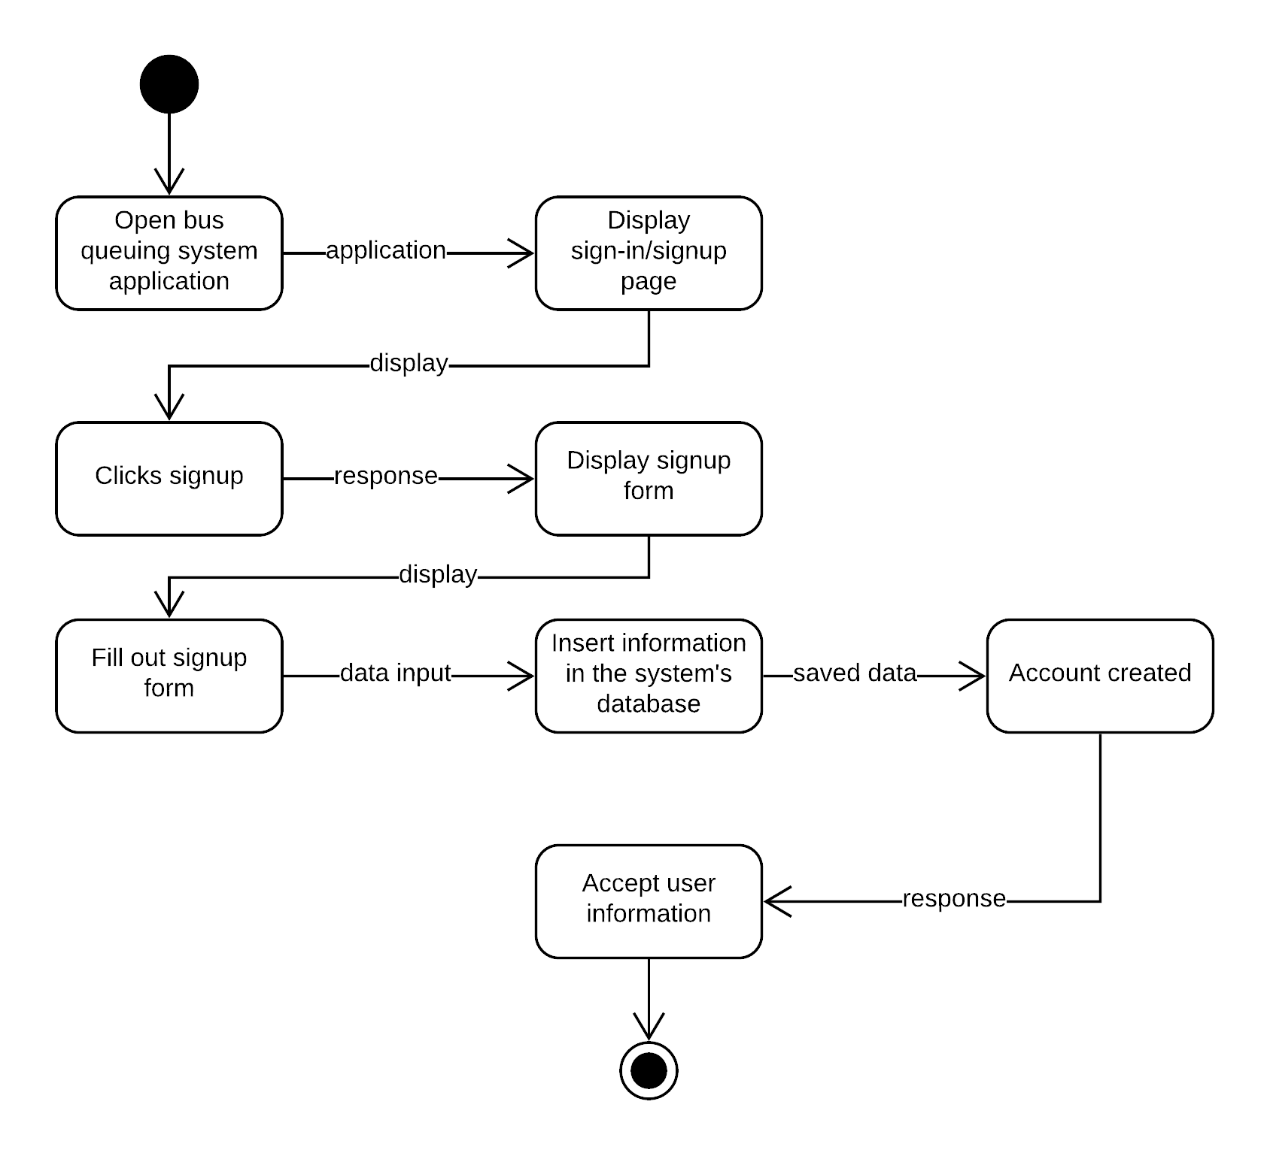

**User Registration State Machine Diagram**

 **b. User Login**

User Login State Machine Diagram

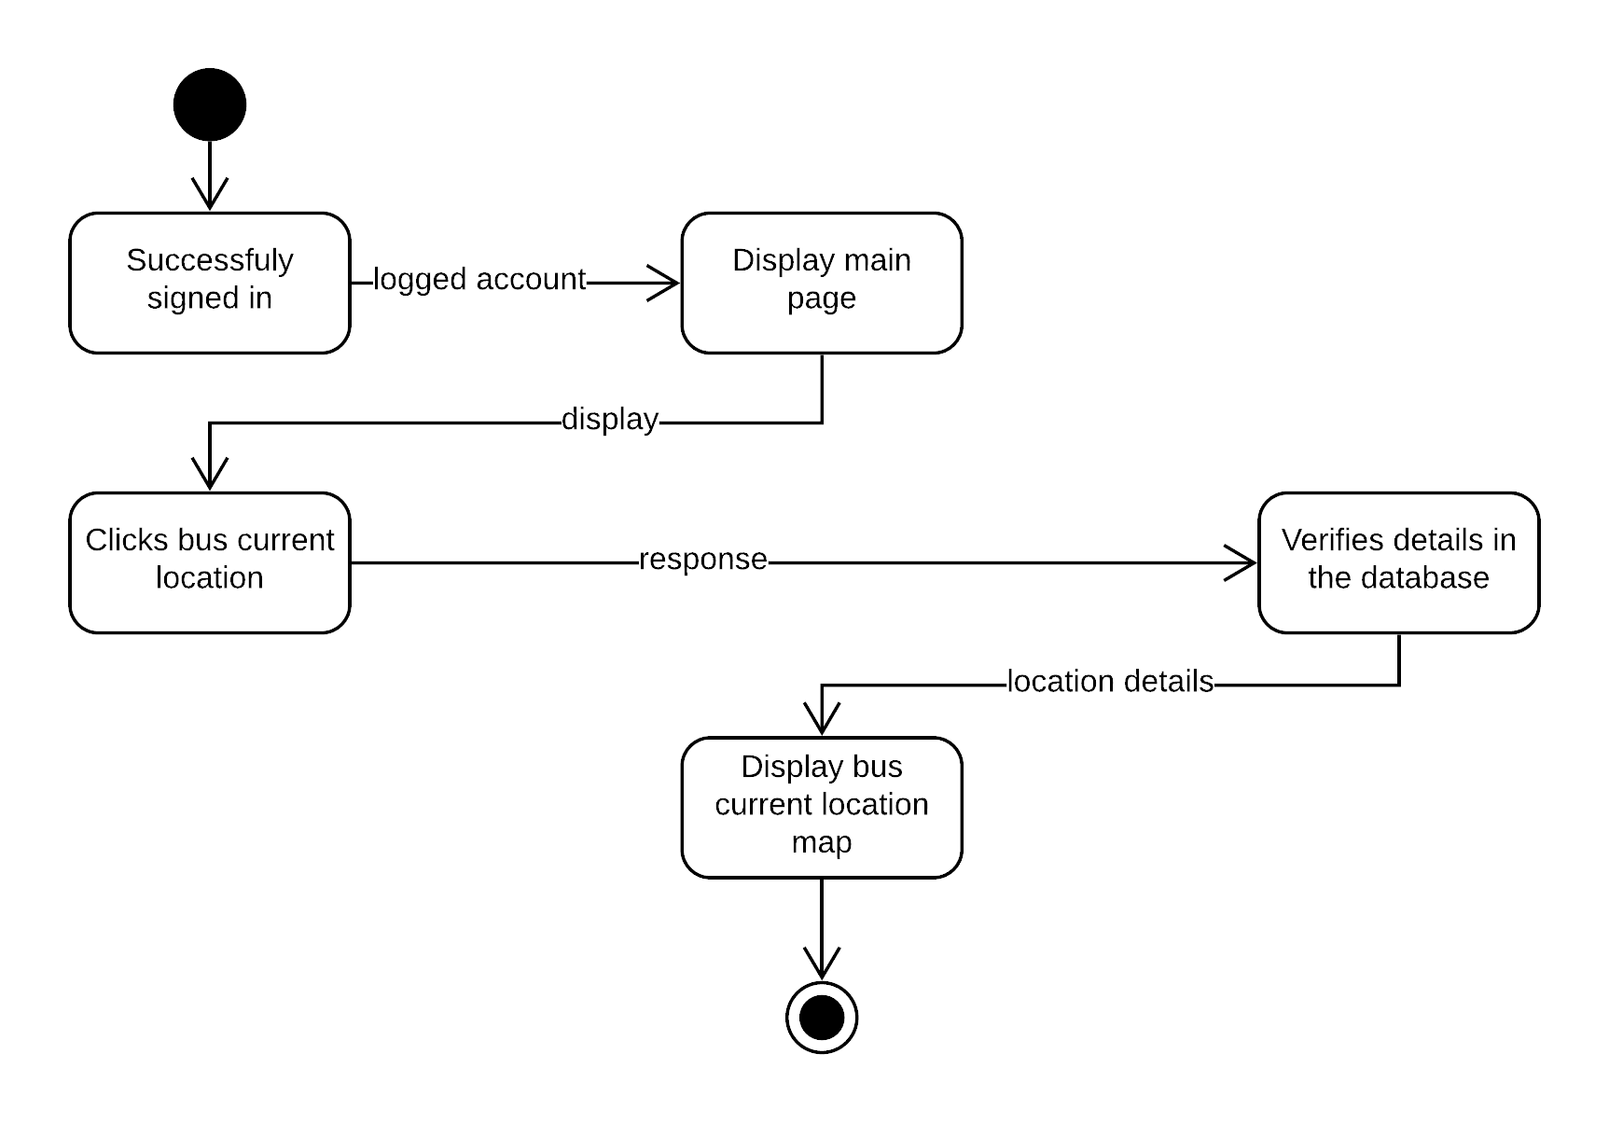 **c. Bus Location**

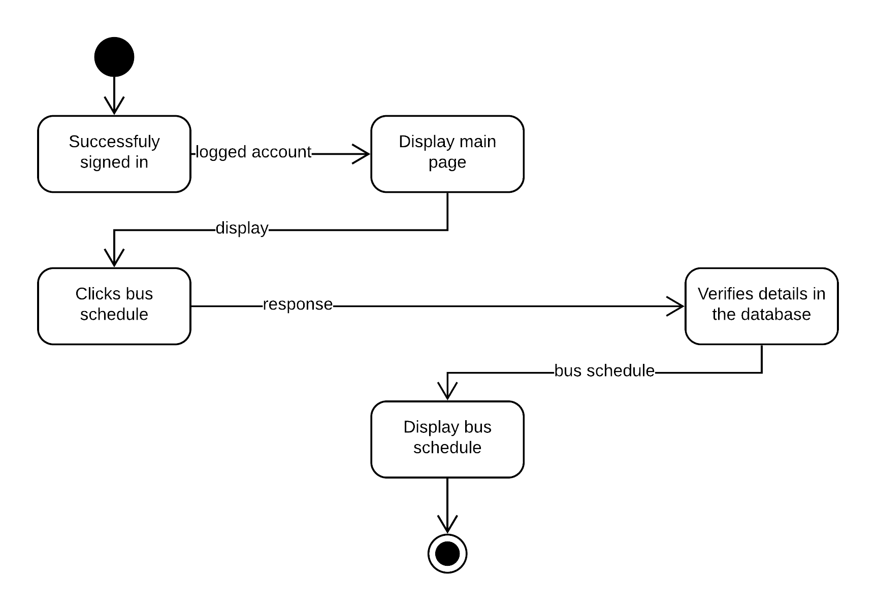 **d. Bus Schedule**

**e. Reserve**

**Reserve** State Machine Diagram



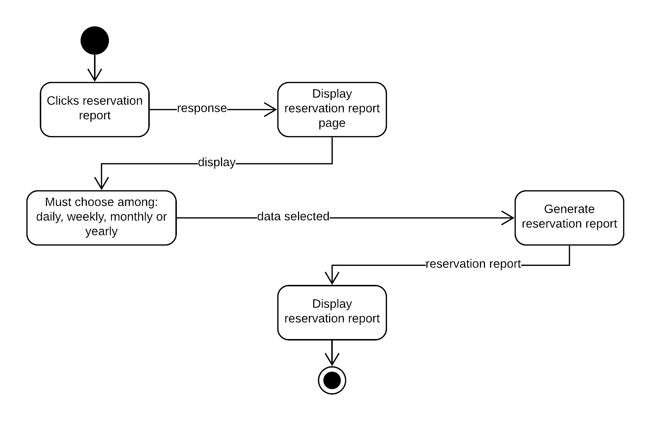 **f. Reservation Report**

**Reservation Report** State Machine Diagram

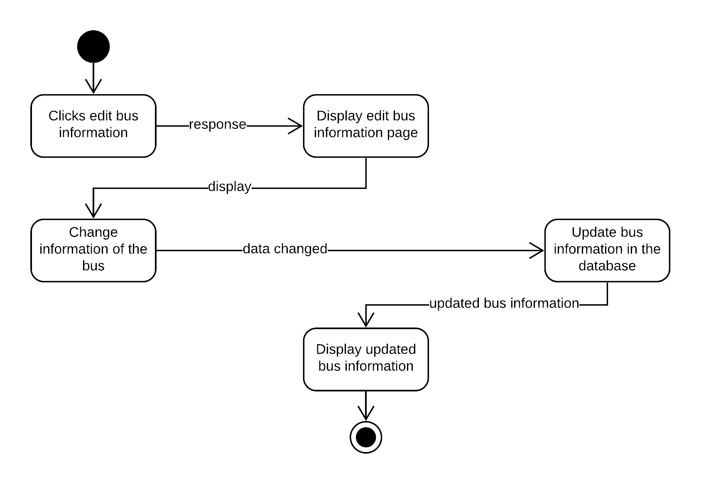 **g. Edit Bus**

**Edit Bus** State Machine Diagram

**3.9 Timing Diagram**

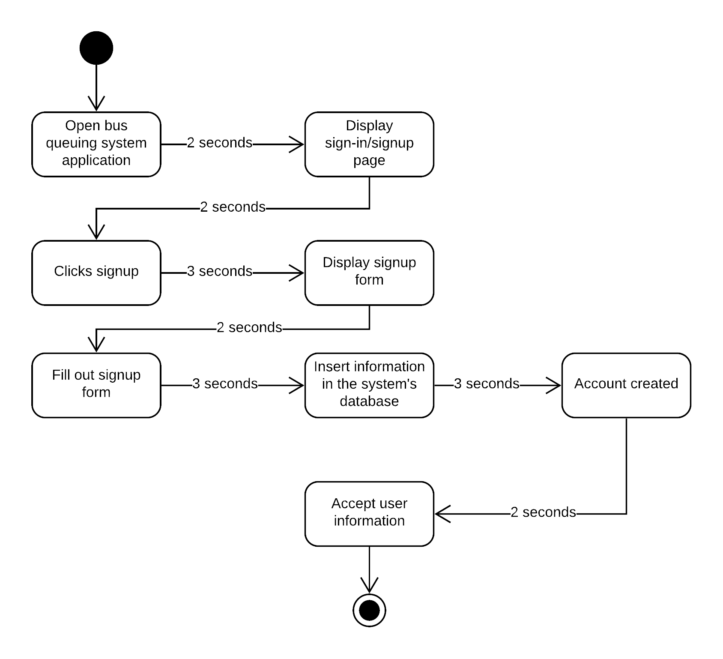 **a. User Registration**

**User Registration Timing Diagram**

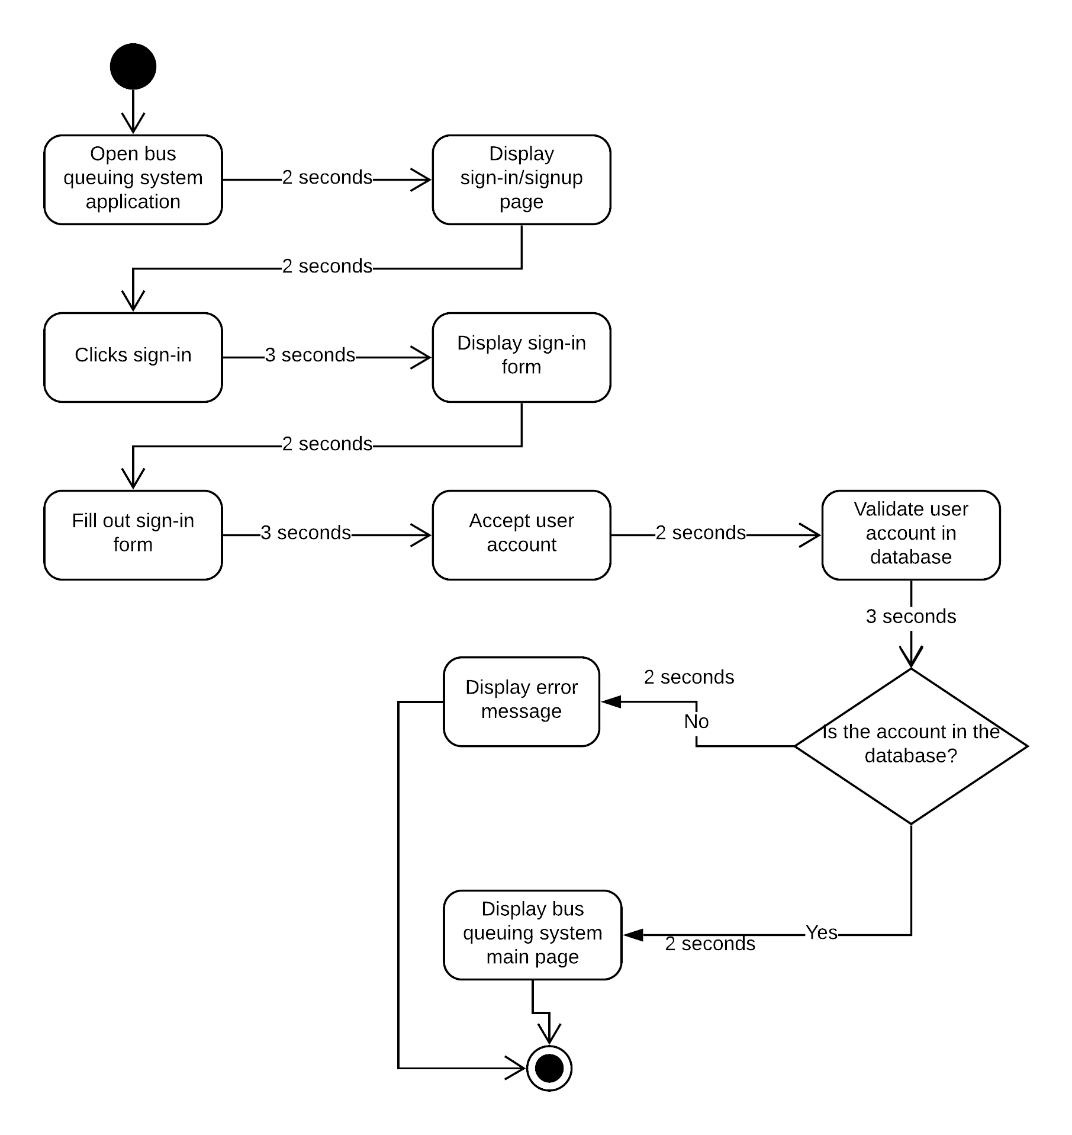 **b. User Login**

**User Login Timing Diagram**

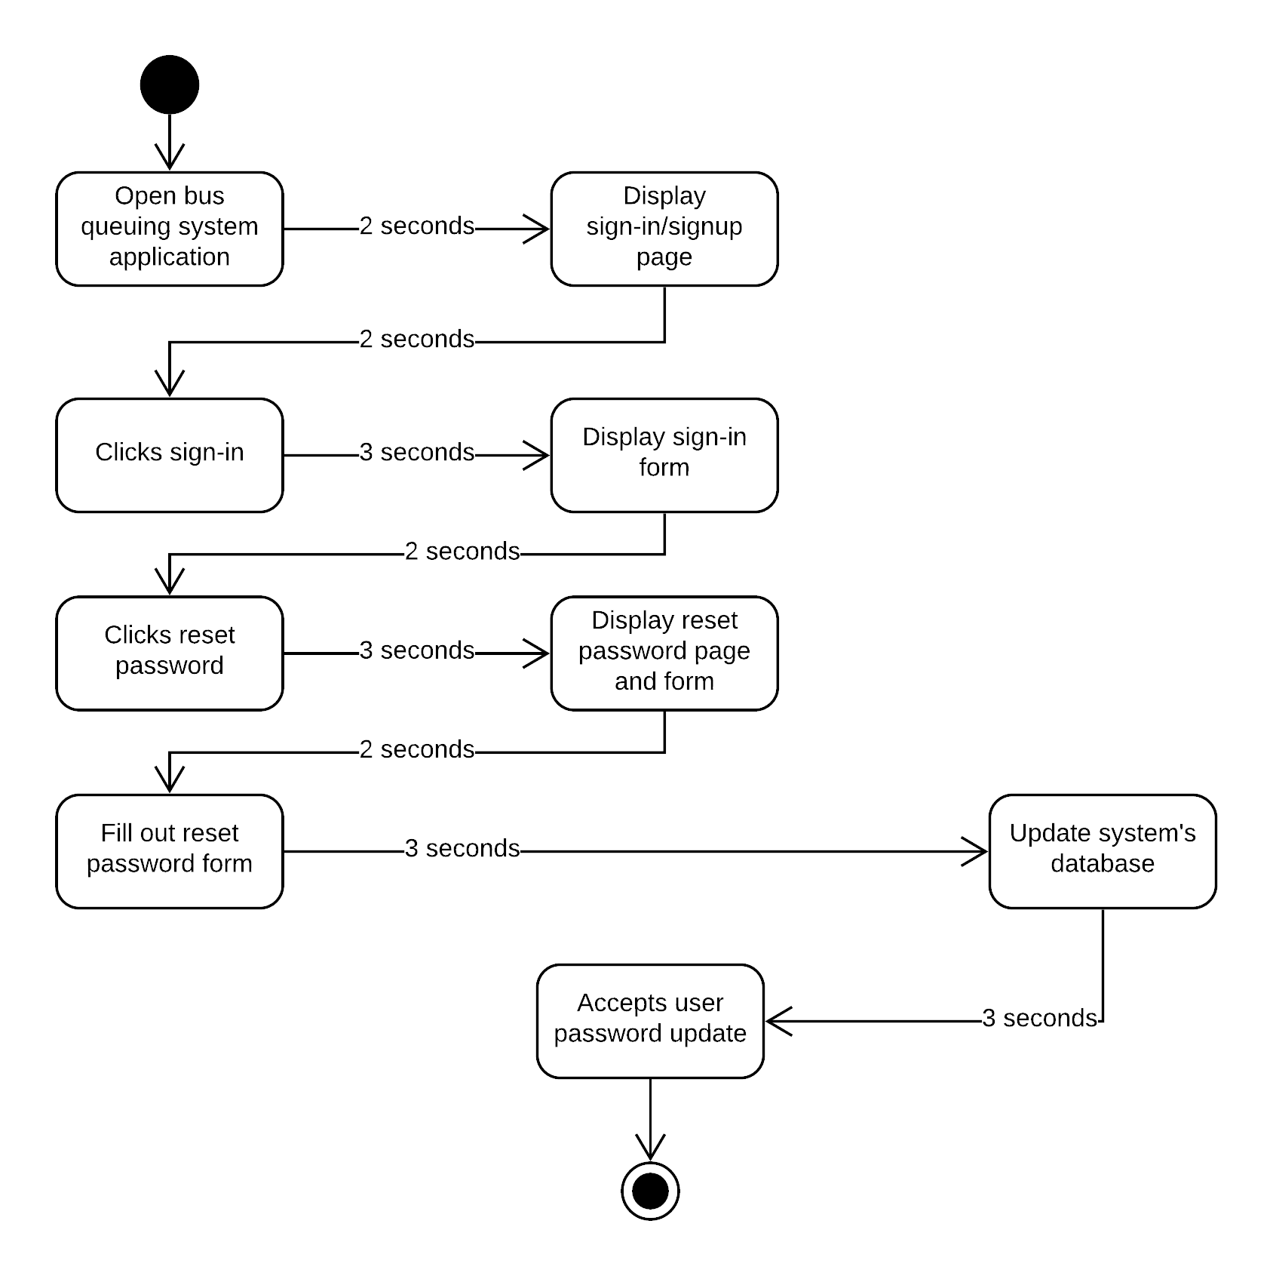 **c. Reset Password**

**Reset Password Timing Diagram**

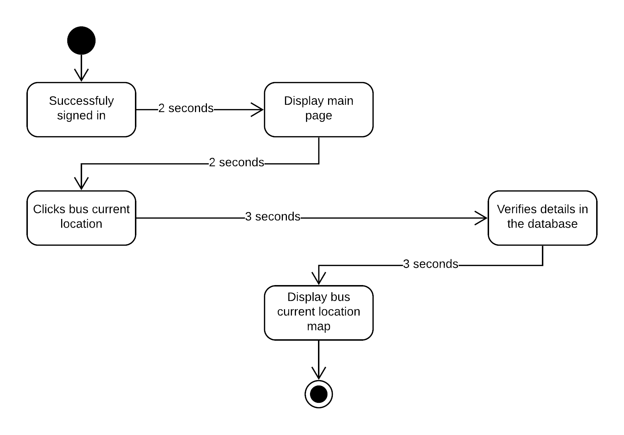 **d. Bus Location**

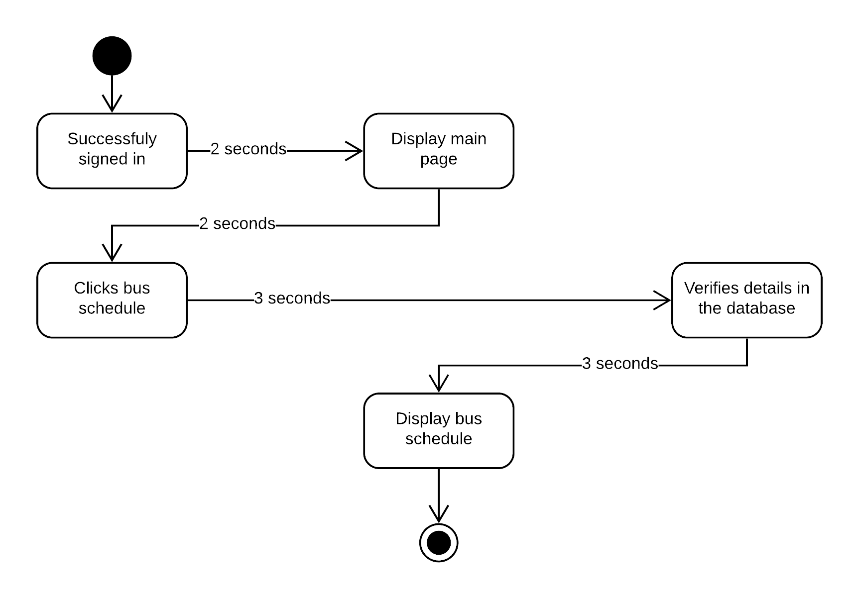 **e. Bus Schedule  
Bus Schedule Timing Diagram**

**f. Reserve**

**Reserve Timing Diagram**

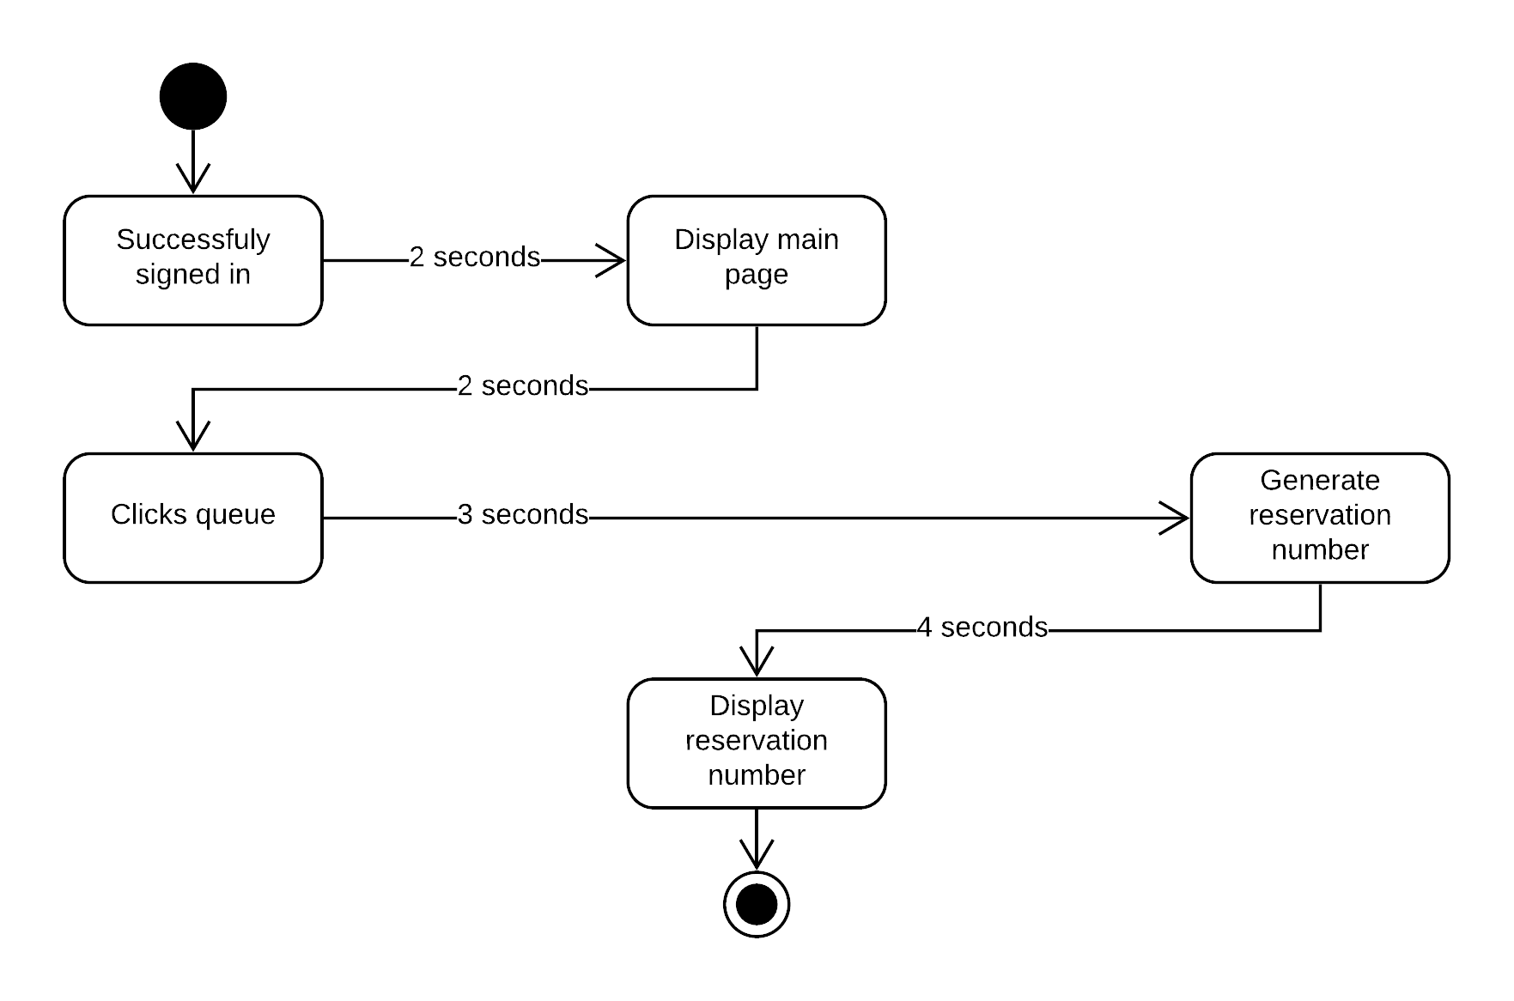

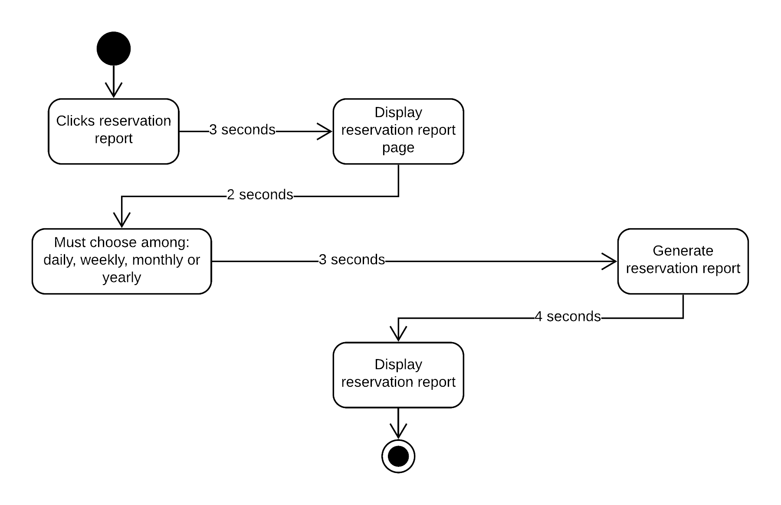 **g. Reservation Report**

**Reservation Report Timing Diagram**

**h. Edit Bus**

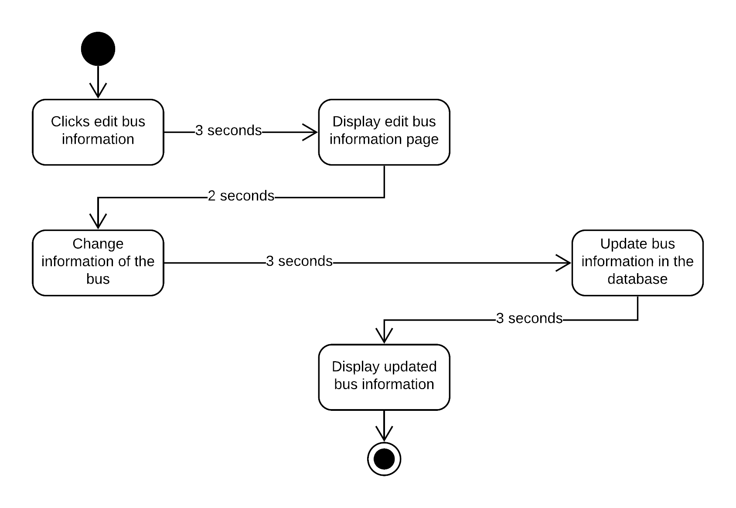

**3.10 Communication Diagram**

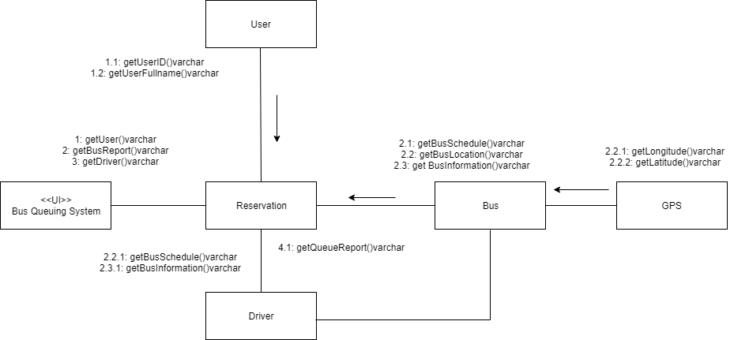

**Communication Diagram**

**3.11 Deployment Diaram**

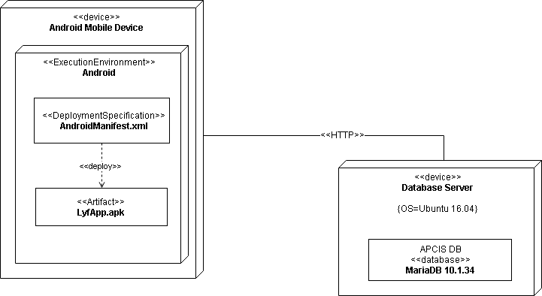

**3.12 Class Package Diagram**

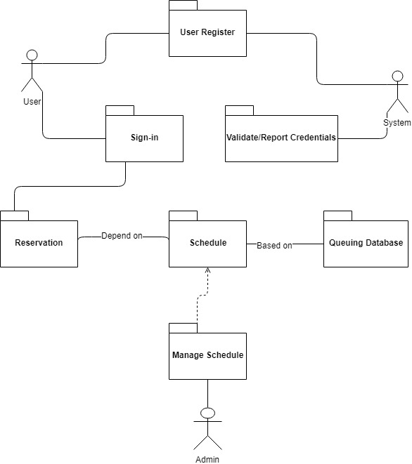

**3.13 Component Diagram**

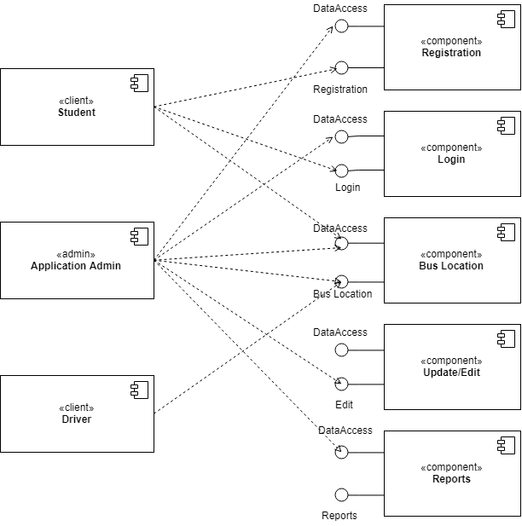

* 1. **Gap Analysis**

|  |  |  |
| --- | --- | --- |
| User Requirements | Current System | Proposed Changes |
| * The user needs to have an Android phone and bus queuing system application * The user requires to have WIFI or data connection to use the application * The user requires to click queue through app to be able to ride a bus | * User queue to use bus services * Users are not aware of the exact location and schedule of the bus * Admins are not aware of the number of passengers riding the bus daily, weekly, monthly and/or yearly * Users can cut in line | * The proposed application lets the user to create an account to be able to use the application * The user must have WIFI or data connection to be able to catch data in the database * The proposed application gives each user their corresponding queuing/reservation number to avoid cutting in line * The proposed application provide reports for the administrator in order to monitor the number of bus users |

* 1. **SWOT Analysis**

|  |  |  |  |
| --- | --- | --- | --- |
| Strength | Weakness | Opportunities | Threats |
| * Provides high level of convenience * Strongly acknowledge the rules and regulation | * Nonconformity with the current bus system * Limited support from hardware/software providers * Lack of Internet connection | * Demand for use of bus services * Innovation | * Competition * Users that are unengaged to the application |

* 1. **Conclusion and Recommendation**
* Conclusion
* This system provides a hassle-free bus queuing system for Asia Pacific College. With this kind of technology, it serves as an answer to the lessen long lines and avoid waiting times of students and faculty.
* Recommendation
* With the evolution of technology, it is more convenient and time less process to do something if we, people, are to enhance and adopt it. Students and Employees of Asia Pacific College can be able to use their time effectively for the application provides technology-based queuing system which practice and value the rules and regulation of the institution. For anyone who wants to upgrade our system. We highly recommend developing a web based application so students who doesn’t have access to the internet can also use the application.

1. **Data Gathering**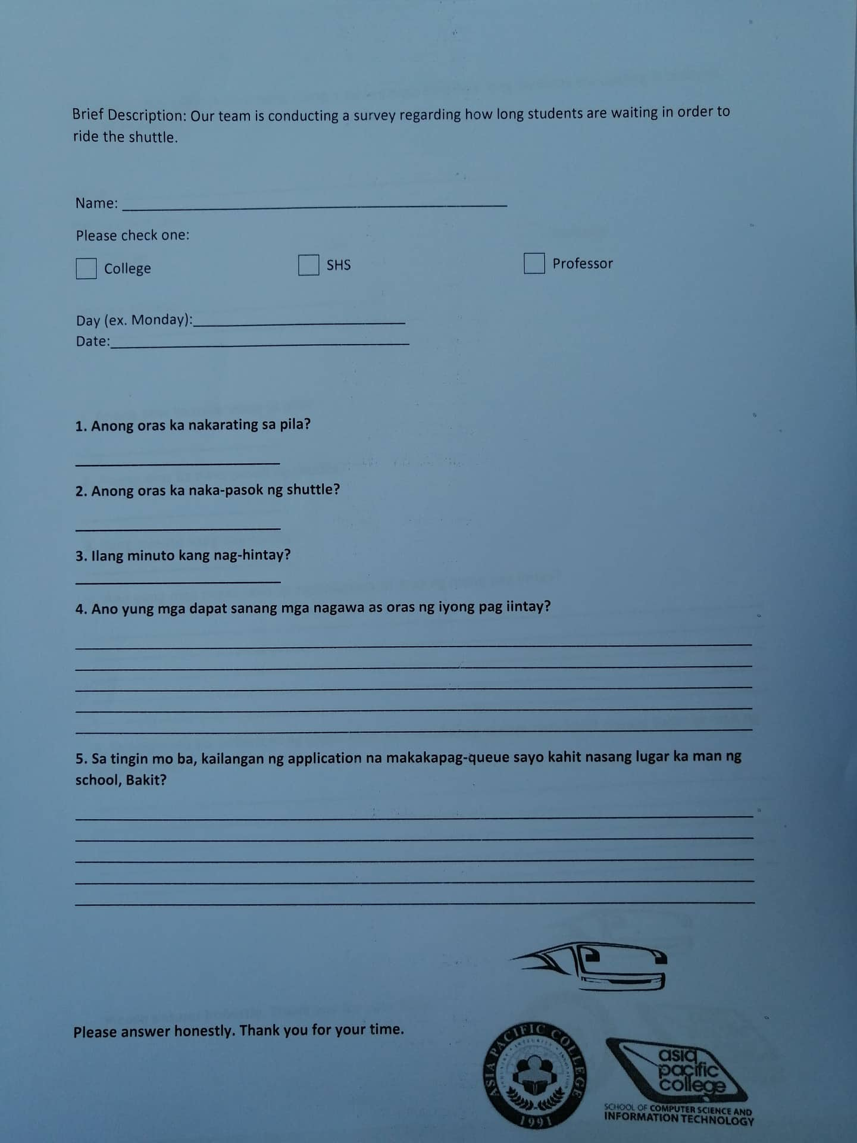

**Data Gathered from Bus Driver**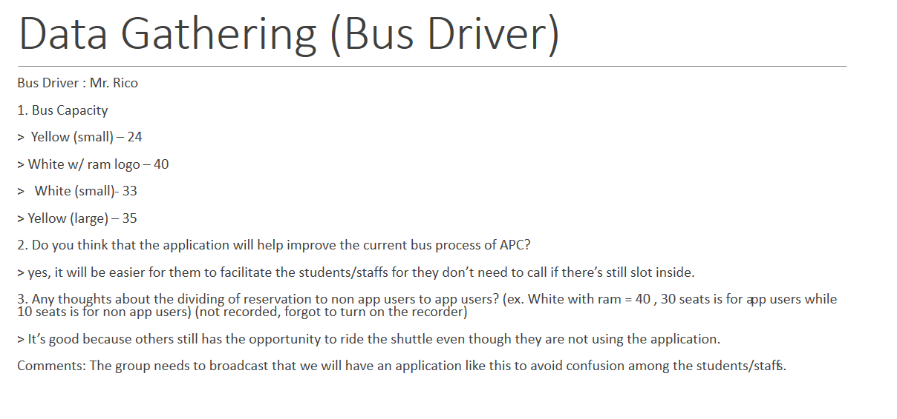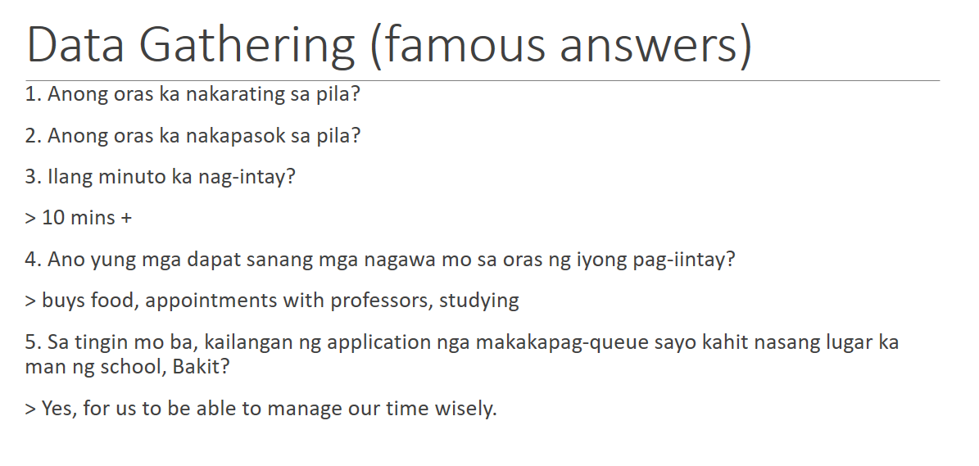

**Data Gathered from individuals of APC Community.**

**Online Form**

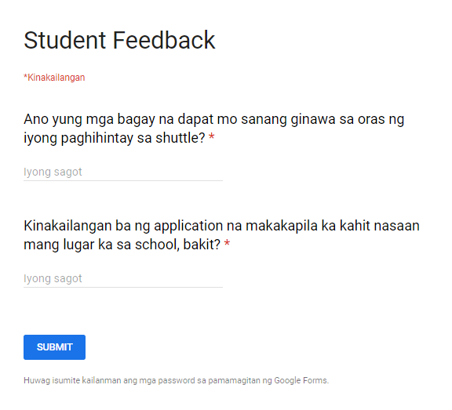

**Results**

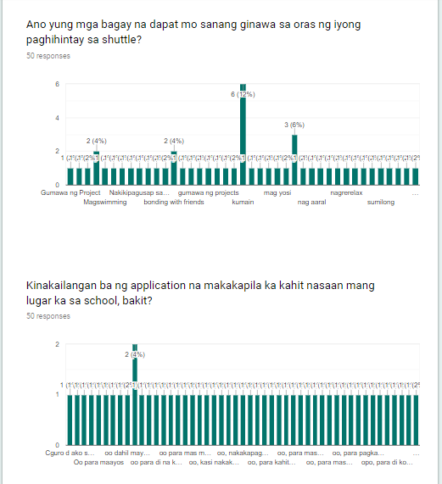

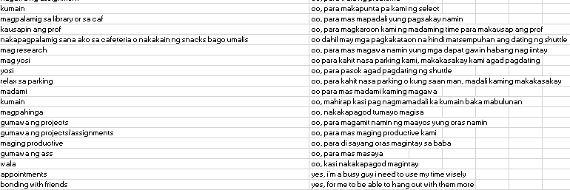

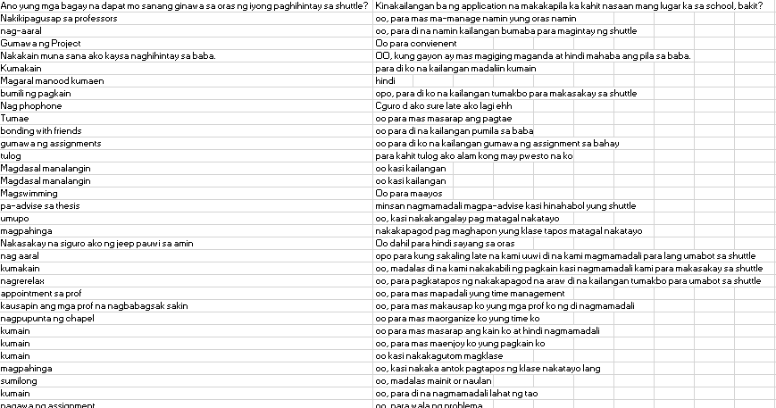

**References**

Uddin, N. et, Al. (2016). Automated Queue Management System. Journal Article. Retrieved from: https://www.academia.edu/21500647/Automated_Queue_Management_System

Tsernov, K. (March 2019). Mowasalat: Effectively Handling Over 7,000 Drivers. Blog. Retrieved from: <https://www.qminder.com/mowasalat-queuing-system/>

<https://docs.google.com/forms/d/1TX5yV6ECVLR-AkVKdQ-Ua73bmZ_HrRLDIlaBQvdc_RM/edit#response=ACYDBNhTcf8tfaH6M535ws_wg5E1k6x_N-b7runWoIVIbSp0PICQESy3gBiRTvWOW8Og114>